Day 1 Setting up and Exploring Linux

# Obtaining Linux on PC – Install Ubuntu using VirtualBox.

Download Ubuntu ISO AMD64 from the website.

<https://ubuntu.com/download/desktop>

Download VMware Workstation from the website.

[VMware Workstation Pro Download - 17.6.3 | TechSpot](https://www.techspot.com/downloads/189-vmware-workstation-for-windows.html#google_vignette)

After that mount ISO and install Ubuntu.

Launch the VM , and after start up installation will go to this interface

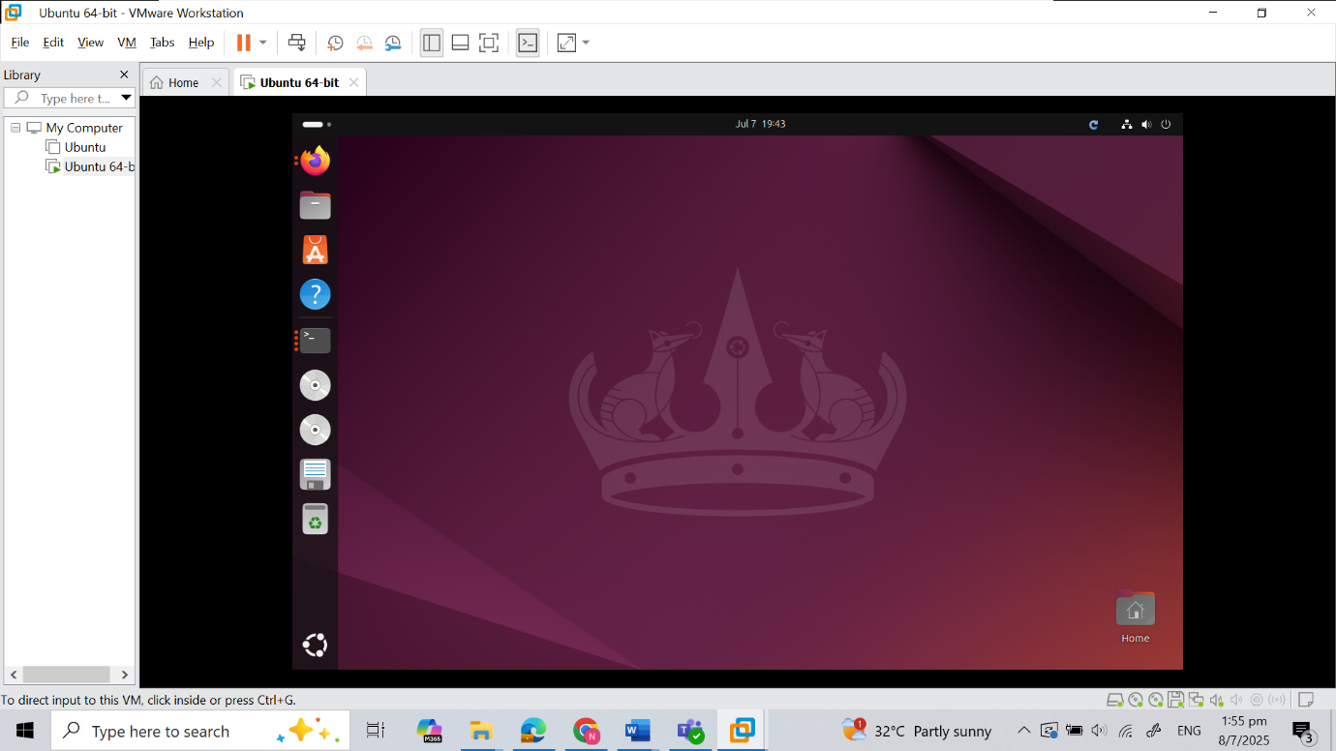

# Familiarity with Ubuntu Linux

Next open terminal and test the command

Do adduser command and familiar with linux command

Ping test

Add user jaychou

Check new user with cat command

Then SSH to the log in jaychou

Download ebooks using wget command

Move into the books directory create earlier and created a ta archive

Then decompressed using bunzip command and extracted with command tar -xvf

# Linux Permissions

Create 3 user – alice, bob, and Mallory and check using command cat

Create new group name sharedgroup, and add alice and bob to the group

Then created 10 files

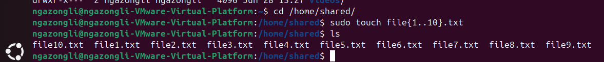

Assigned the group to the folder and its content, used chmod to set permission to user alice

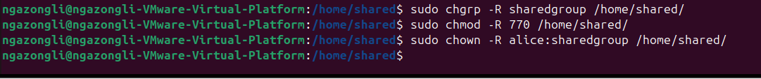

Alice is able to access and write to the file

Bob is able to write to the file too as I set chmod 770

After chmod to 750

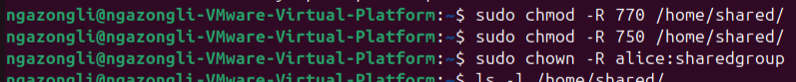

Bob only can read and execute file now

Mallory couldn’t access the folder at all

# Searching filesystems

Use the previous tar.bz2 file

Bunzip2 to extract the archive

Find command to find txt file inside folder

Grep -r command to find keywords in the folder

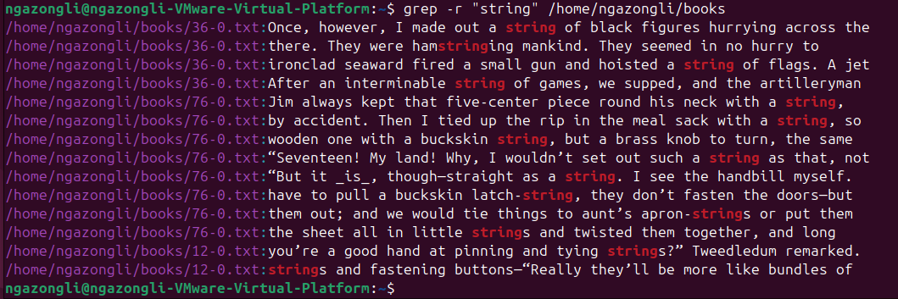

Grep -r -c to find context in the text file

Command to find the largest files in the filesystem

Investigating the frequency of element in a file

